# **ASSIGNMENT NO-15**

Problem Statement:- **Create server less computing service**.

Steps:-

1. **Sign in.** Sign in to your **AWS account.**
2. Search **lambda** and **click on it**.

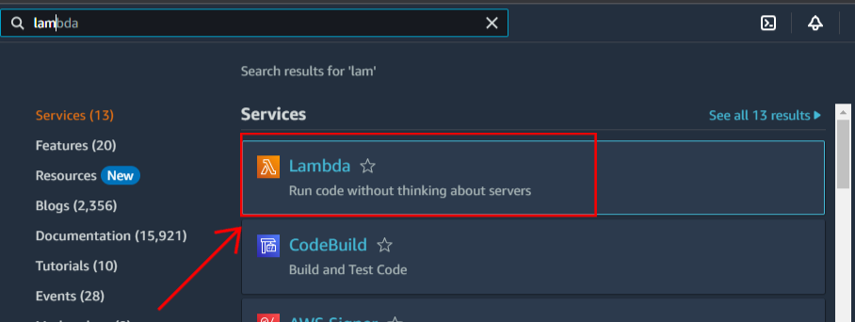

1. Click on **Create a function**.

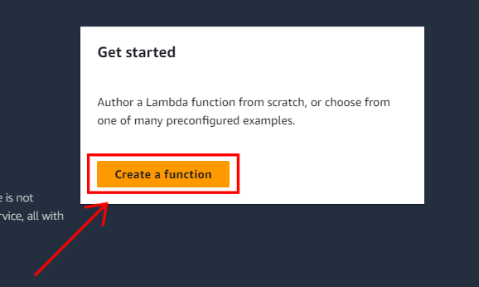

1. Set the **Create function info as Author from scratch**, give the **name of the function** and set the **runtime info as Node.js.18.x**.

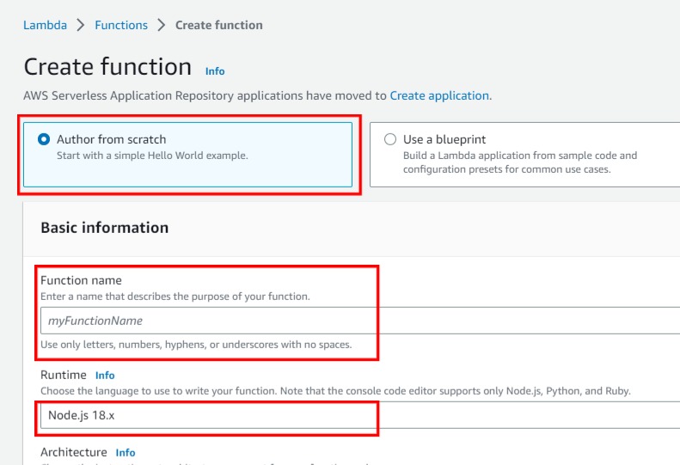

1. Set the **Architecture info as x86_64** and click on **Create function**.

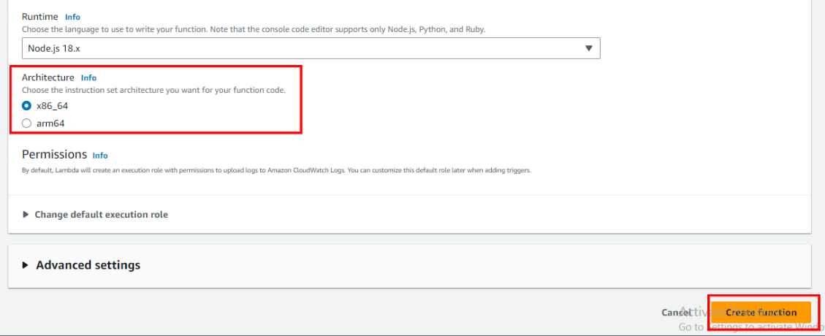

1. Now your function is created successfully, now **scroll down in the code source**, **edit the code as per your requirement** and **click on file** and **click on save** of save the edited code.

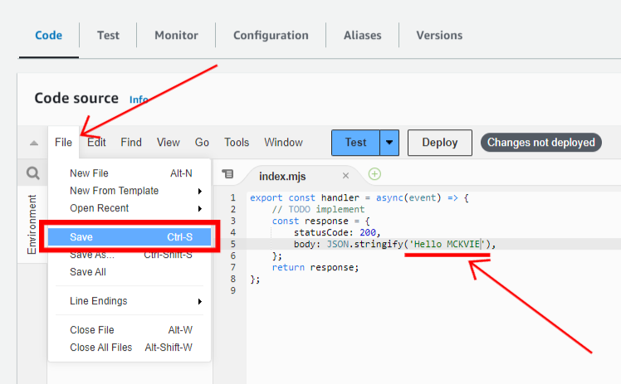

1. Now go to **configuration**, then click on **Function URL** and after that click on **Create Function URL**.

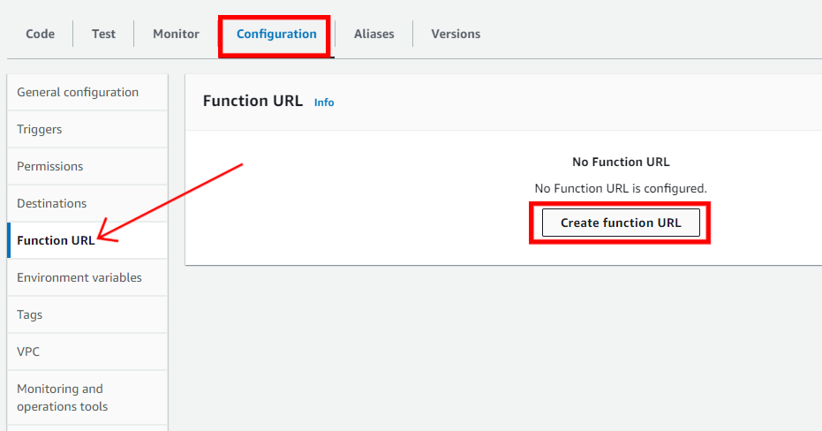

1. Set the **Auth type as NONE**.

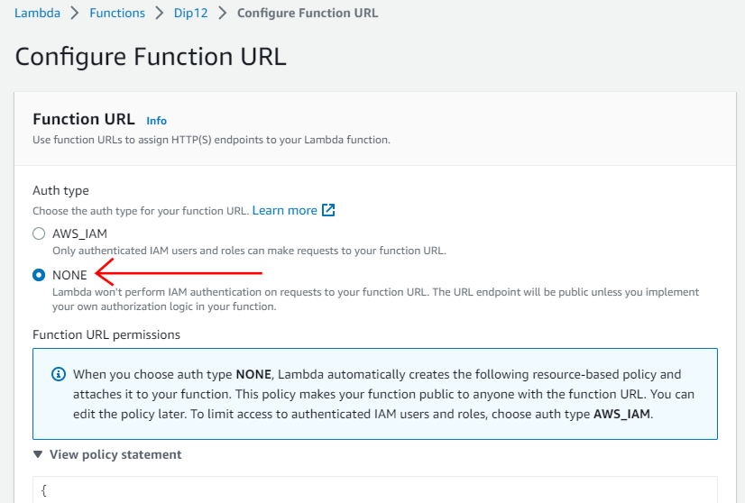

1. Now click **save**.

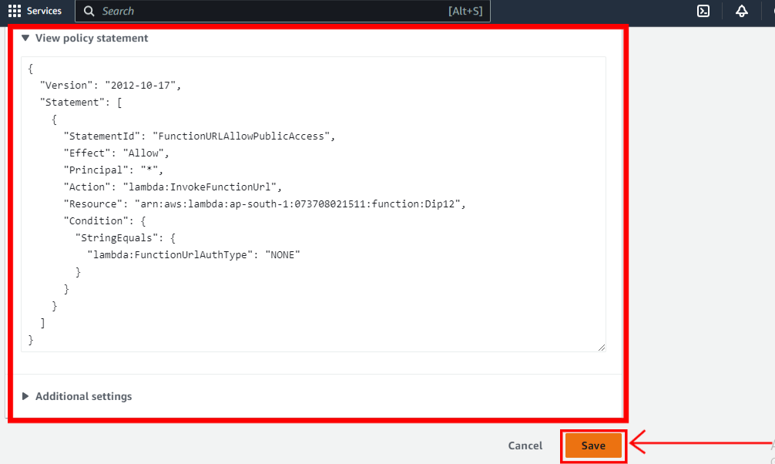

1. Now **copy the Function URL** and open it on a new tab.

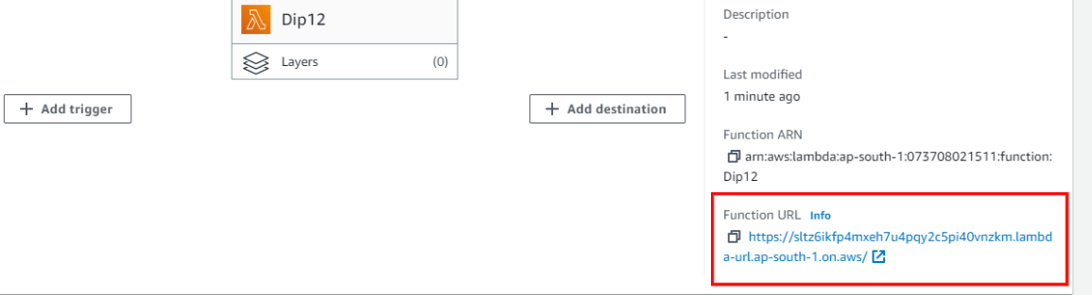

1. The Function URL is working.

